Mechanics of Materials Laboratory
Principal Stresses and Strains

Abstract
Principal stress refers to the magnitudes of stress that occur on certain planes aligned with a solid body of which they occur. For a rectangular beam, a corner of the beam could be thought of as the origin of this coordinate system with each of the planes parallel to the three touching faces of the beam at that point. In the following experiment, two principal stresses and strains were determined using a rosette, an array of three strain gauges. When a 3.77 lb load was applied to a beam measuring 1" x 0.125" x 11.250" demonstrated a principal strain of 1528 and -463 με longitudinally and laterally (respectively) at 1 inch from the clamp. The stress was therefore calculated to be 15.9 and 0.0 ksi longitudinally and laterally (respectively) at the same position.
Table of Contents
1. Introduction & Background 2
1.1. General Background 2
1.2. Determination of Principal Stresses 2
2. Equipment and Procedure 2
2.1. Equipment 2
2.2. Experiment Setup 2
2.3. Initial Calibration 2
2.4. Procedure 2
3. Data, Analysis & Calculations 2
3.1. Known information 2
3.2. Gage Readings 2
3.3. Further Calculations 2
4. Results 2
5. Conclusions 2
6. References 2
7. Raw Notes 2

Introduction & Background

General Background
When a cantilever beam experiences a single load, the magnitude of the stress can be modeled as a directional result. Since stress is difficult to visualize, an important relation to help explain this phenomenon is the relation between stress and strain. Since strain can be seen visually, it is easy to confirm the amount of strain occurring longitudinally is far greater than the lateral strain. The same is true of stress.
Principal stresses refer to the magnitudes of stress that occur on certain planes within a solid body. This coordinate system is aligned such that no shear stresses occur along these principal planes. For a rectangular beam, a corner of the beam could be thought of as the origin of this coordinate system with each of the planes parallel to the three touching faces of the beam at that point.

Determination of Principal Stresses
Principal stresses can be determined simply by aligning strain gages along axis. The procedure below explains how to use a rosette, an array of strain gages placed in different orientations around a single point, to determine principal strains.
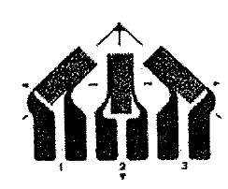
Figure 1
To perform the required analysis, consider a rectangular rosette with an axis aligned to one of the gages. The strain at any angle can be found using a set of expressions in the form of the following.
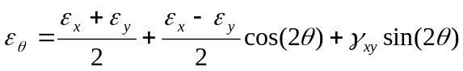
Equation 1
Applying Equation 1 to each of the three gages with θ measured counterclockwise from the x axis, expressions for 1, 2, 3 can be formed.
For a rectangular rosette, the two principal strains along the two-dimensional surface is characterized by
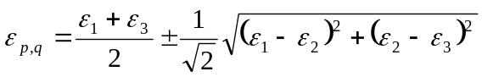
Equation 2
and
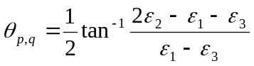
Equation 3
Stress can commonly be calculated by using Hooke's Law. Since the strains measured are not aligned with the load and resulting stress, the generalized form of Hooke's Law is used.
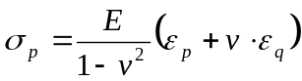
Equation 4
and
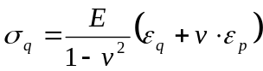
Equation 5
where E is the elastic modulus.

Equipment and Procedure

Equipment
- Cantilever flexure frame: A simple apparatus to hold a rectangular beam at one end while allowing flexing of the specimen upon the addition of a downward force.
- Metal beam: In this experiment, 2024-T6 aluminum was tested. The beam should be fairly rectangular, thin, and long. Specific dimensions are dependant to the size of the cantilever flexure frame and available weights.
- P-3500 strain indicator: Any equivalent device that accurately translates to the output of strain gages into units of strain.
- One rectangular rosette:
- Micrometers and calipers:

Experiment Setup
The specimen should be secured in the flexure frame such that an applied force can be placed perpendicular and opposite of the securing end of the fixture. A rosette containing three strain gages should be mounted as shown in figure one. In this setup, θ_{p} and θ_{q} are known.
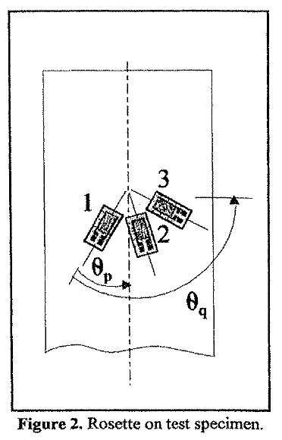
Figure 2

Initial Calibration
Record the dimensions of the beam, as well as the gage factor for each strain gage. Strain gage specifications are usually provided by the manufacturer. Before any deflection is added on the beam, the strain indicator should be calibrated using the gage factor the gage 1 (labeled below.) Since there is no forced deflection, the indicator should be balanced such that a zero readout is achieved.

Procedure
Utilizing a quarter bridge configuration, measure and record each of the individual strain gage readings. The gage factor should be readjusted if the gage factor varies for any of the gages.
After the last gage result has been measured, a known load should be applied to a point. This location should be at a known length from the clamp of the flexure fixture, as well as be located in the center of the bar laterally.
The strain for each gage should be measured in reverse order. It is important that the gage factor be readjusted for each location. Upon completion of recording the measurements, the load should be removed from the bar and the indicator should return to the initial zero reading.

Data, Analysis & Calculations

Known information
The applied load was 3.77 pounds.
The following table catalogs other known information within this experiment setup.
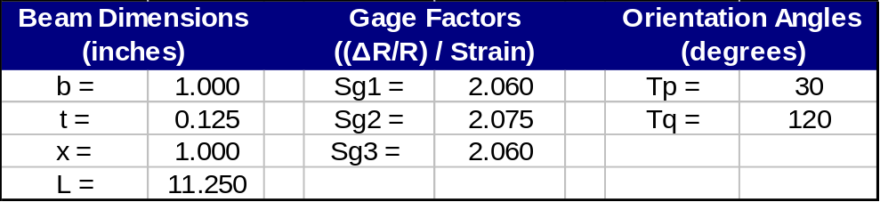
Table 1

Gage Readings
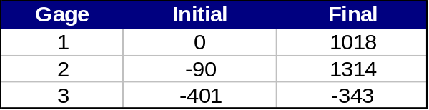
Table 2
To find the strain induced by the deflection, the net strain was found by,
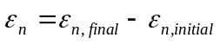
Equation 6
The table below catalogs the net strains by each gage.
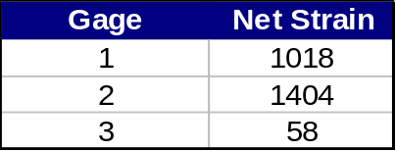
Table 3

Further Calculations
The principal strains ε_{p} and ε_{q}, is found using Equation 2.
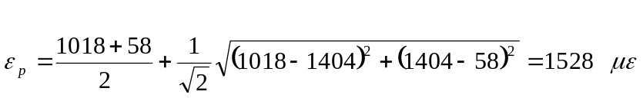
Equation 7
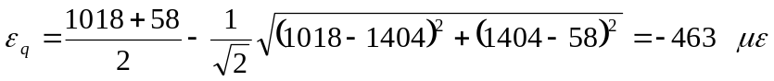
Equation 8
Poisson's ratio is defined as the lateral strain divided by the longitudinal strain. Expressed mathematically,
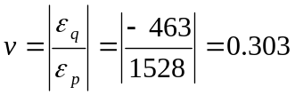
Equation 9
Equation 3 is used to determine the angle between Gage 1 and the principal axes.
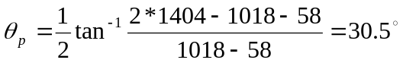
Equation 10
The stress along the principal axes is determined from the generalized Hooke's Law, as expressed in Equation 4 and 5.
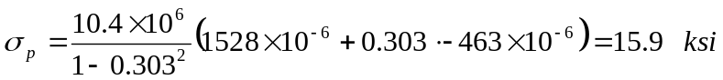
Equation 11
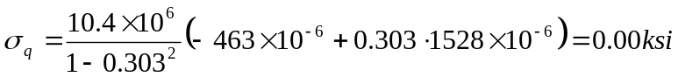
Equation 12
As a comparison, theory can be used in calculating the principal stresses.
Equation 13
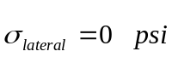
Equation 14

Results
Utilizing Equation 1, ε_{p} and ε_{q} were found to be 1528 and -463 με respectively. This corresponds to a Poisson's ratio of 0.303. This corresponds to a 1% error from the theoretical value 0.3. Possible sources for this error is the uncertainty of the machine, and imperfections in the adhesive used to secure the strain gage.
The angle at which the gage was placed was calculated to be 30.5º, which varies by 1.67%.
Utilizing Hooke's Law, the longitudinal and lateral strain was calculated to be 15.9 and 0 ksi respectively. Though the lateral stress contains no error, the longitudinal stress exhibited a 7.43% error from the theoretical 14.8 ksi.

Conclusions
The results generated within this experiment demonstrated high integrity when compared against the theoretical values, and therefore are acceptable for a starting point in design verification. The rosette is a powerful tool for determining stress along a 2-D plane.

References
Gilbert, J. A and C. L. Carmen. "Chapter 8 – Cantilever Flexure Test." MAE/CE 370 – Mechanics of Materials Laboratory Manual. June 2000.
Kuphaldt, Tony R. (2003). "Chapter 9 – Electrical Instrumentation Signals." AllAboutCircuits.com. Retrieved September 19, 2006, from Internet: "http://www.allaboutcircuits.com/vol_1/chpt_9/7.html

Raw Notes
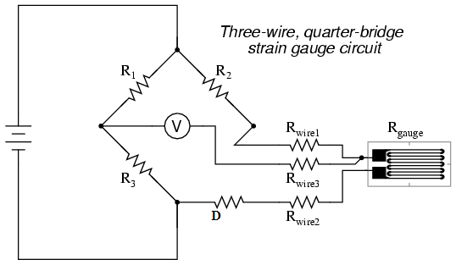
Figure 3
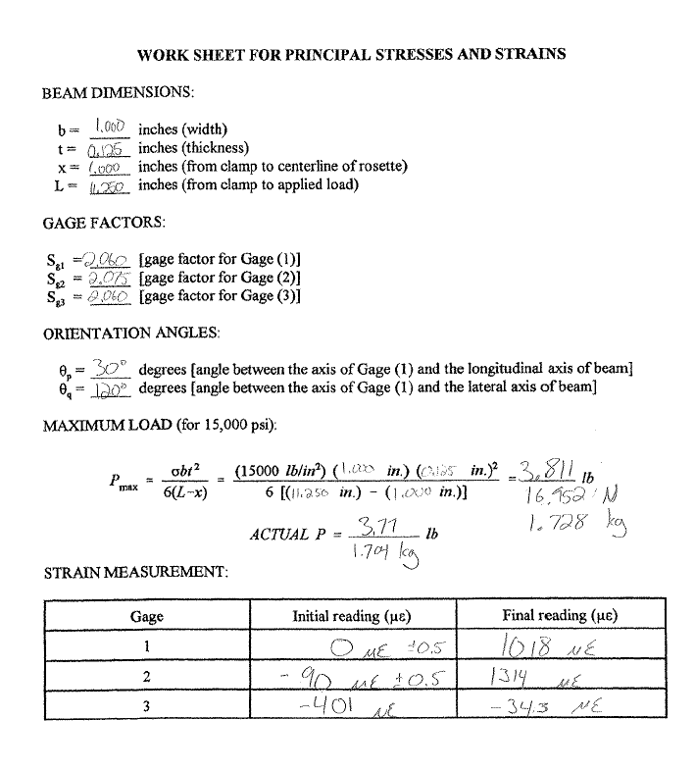
Figure 4
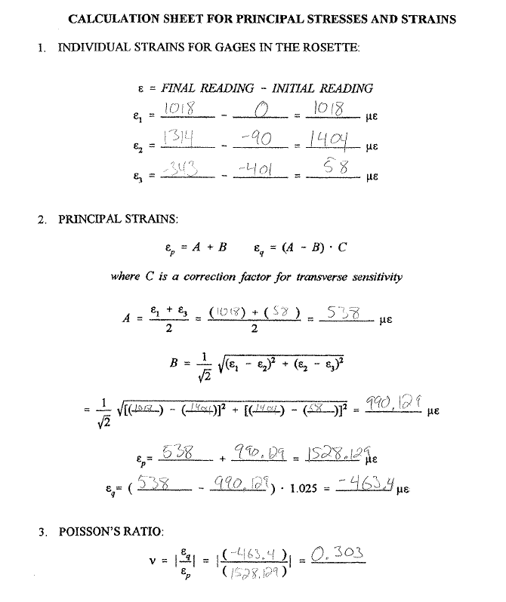
Figure 5
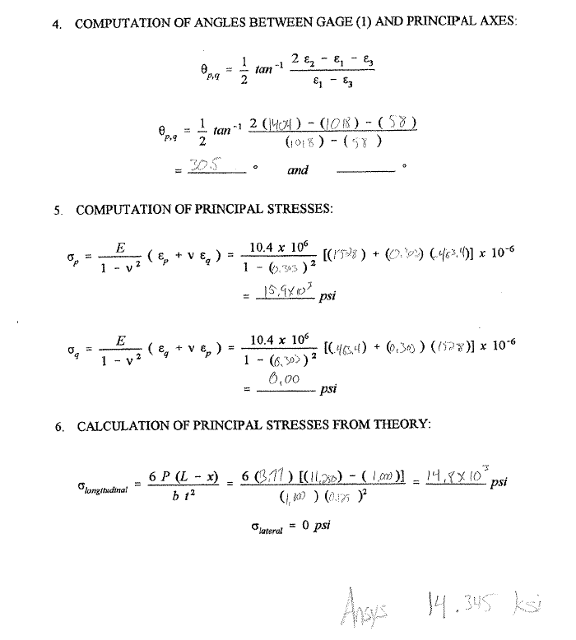
Figure 6

